**Detecting Disaster Tweets**

Abdullah Mohammad Ahmad AbuZeidan 0201393

Omar Eihab Saleh Zamil 0204071

Zaid Bassam Al-Surakhi 2200142

Lujain Thaer Alrousan 0203321

Shaima Riyad Khraisat 0204805



ARTIFICIAL INTELLIGENCE DEPARTMENT

KING ABDULLAH II SCHOOL OF INFORMATION TECHNOLOGY

THE UNIVERSITY OF JORDAN



**ABSTRACT**

Twitter has become an important communication channel in times of emergency. The ubiquitousness of smartphones enables people to announce an emergency they’re observing in real-time. Because of this, more agencies are interested in programmatically monitoring Twitter (i.e. disaster relief organizations and news agencies).

So, we recognize the imperative of harnessing the power of Natural Language Processing (NLP) to efficiently decipher the wealth of information embedded in tweets during emergencies. Through this lens, our project endeavors to provide a systematic, real-time, and intelligent solution for agencies navigating the complexities of emergency communication on Twitter.

**ACKNOWLEDGMENTS**

After thanking God for everything, we would also like to extend our appreciation to our lecturer, **Dr. Tamam Al-Sarhan**, for granting us the opportunity to work on the project "Detecting Disaster Tweets." His guidance and support have been instrumental in conducting thorough research to articulate our information and knowledge effectively.

**CONTENTS**

ABSTRACT 2

ACKNOWLEDGMENTS 3

CONENTS 4

LIST OF TABLES 5

LIST OF SYMBOLS AND ABBREVIATIONS 5

References 20

**Chapter One: Introduction 6**

* 1. Preamble 6
  2. Problem Statement 6
  3. Project Aim and Objectives 7
  4. Project Software and Hardware Requirements 8
  5. Project Schedule 9

**Chapter Two: Related Existing Systems 10**

* 1. Introduction 10
  2. Existing Systems 10

**Chapter Three: System Requirements Engineering and Analysis 13**

* 1. Datasets 13
  2. Model Reports 16
  3. Approach 18

**Chapter Four : System Design & Implementation 19**

* 1. Datasets 19
  2. Model Reports 19

**LIST OF TABLES**

Table 1: Software requirements 8

Table 2: Hardware requirements 8

Table 3: Project Schedule Management 9

**LIST OF FIGURES**

Figure 1: Gant Chart 9

Figure 2: BERT & DistilBERT 19

Figure 3: Code Implementation 19

**LIST OF SYMBOLS AND ABBREVIATIONS**

|  |  |
| --- | --- |
| BERT | Bidirectional Encoder Representations from Transformers |
| DistilBERT | Distillation BERT |

1. **Chapter One: Introduction**
   1. **Preamble:**

In the age of digital interconnectedness, social media platforms, particularly Twitter, have emerged as indispensable tools for real-time communication. It is here, in this vast sea of information, that our project takes root.

Twitter has become a lifeline during emergencies, allowing individuals to share firsthand accounts of disasters as they unfold. However, the sheer volume of data generated during such events poses an unprecedented challenge for timely and efficient analysis.

* 1. **Problem Statement:**

In the fast-paced world of emergency response, time is of the essence. Traditional methods of monitoring and interpreting the vast volume of tweets generated during disasters present significant challenges. The manual sorting of information is time-consuming and often prone to oversight, hindering the efficiency of emergency response efforts.

Recognizing these challenges, the need for automated solutions becomes apparent. Disaster relief organizations and news agencies require a tool that can swiftly and accurately analyze the dynamic language of tweets, enabling them to make informed decisions and respond proactively to unfolding emergencies. This involves leveraging the capabilities of the DistilBERT model. **(Addison Howard, devrishi, Phil Culliton, Yufeng Guo. (2019).** [**Natural Language Processing with Disaster Tweets**](https://www.kaggle.com/competitions/nlp-getting-started/data)**)**

* 1. **Project Aim and Objectives:**

The main objectives of this project include:

1. Real-time Monitoring:

* Enable real-time tracking and monitoring of tweets related to disasters.
* Reduce response times by promptly identifying critical information within the Twitter data stream.

1. Language Understanding:

* Develop NLP algorithms capable of understanding the nuances and context of disaster-related language in tweets.
* Enhance the accuracy of sentiment analysis to discern urgency and severity levels.

1. Contextual Analysis:

* Provide insights into the geographical spread and impact of disasters based on Twitter data.
  1. **Project Software and Hardware Requirements:**
* Software requirement:

Table (1): Software requirement.

|  |  |
| --- | --- |
| **Requirement** | **Software** |
| Windows 8.1 or higher operating systems | Operating system |
| Microsoft Edge, Firefox, Safari, and Google Chrome. | Browser |
| Python | Development Tools |

* Hardware requirement:

Table (2): Hardware requirements.

|  |  |
| --- | --- |
| **Requirement** | **Hardware** |
| Core i5 - 1480 MHz Pentium minimum, V - 1 GHz or higher recommended | Computer |
| Intel Core 3 Duo E7300 Opteron / Xeon Server CPU(Opteron 2356/Xeon5300)ييلا | CPU |
| 8 GB | Memory (RAM) |
| 500 GB | Hard disk |

* 1. **Project Schedule:**

Project management is declared as planning, organizing, securing, and managing resources to achieve specific goals. The following table displays the project management: **(****Mettler, Cory. (2023).** [**Developing Gantt Charts**](https://www.researchgate.net/publication/371231777_Developing_Gantt_Charts)**.)**

|  |  |  |  |  |  |
| --- | --- | --- | --- | --- | --- |
| **Task** | **Description** | **Start time** | **End Time** | **Duration** | **Dependency** |
| T1 | Planning | 10/27/23 | 10/31/23 | 5 Days |  |
| T2 | Information Gathering | 10/30/23 | 10/03/23 | 3 Days | T1 |
| T3 | Analysis | 11/03/23 | 11/14/23 | 10 Days | T2 |
| T4 | Design | 11/04/23 | 11/12/23 | 7 Days | T3 |
| T5 | Implementation | 11/05/23 | 12/16/23 | 30 Days | T4 |
| T6 | Testing | 12/17/23 | 12/23/23 | 5 Days | T5 |
| T7 | Documentation | 10/27/23 | 12/25/23 | 44 Days | T1, T2, T3, T4, T5, T6 |
| T8 | Submission | 01/04/24 | 01/04/24 | 1 Day | T7 |

Table (3): Project Schedule Management in developing.

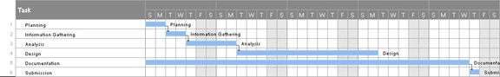

Figure (1): Gant Chart.

1. **Chapter Two: Related Existing Systems**
   1. **Introduction:**

several systems and research projects were related to natural language processing (NLP) for disaster response and social media analytics.

* 1. **Existing Systems:**

**TweetTracker (2022):** generally refers to tools or platforms designed for monitoring, analyzing, and tracking tweets on the social media platform Twitter. These tools often offer functionalities such as real-time monitoring, analytics, search and filtering options, hashtag tracking, and user mentions and interactions. Users, including businesses, researchers, or social media professionals, can utilize TweetTracker-like tools to gain insights into Twitter data, track specific topics or keywords, analyze user engagement, and understand trends on the platform. Keep in mind that the specific features and capabilities may vary among different tools with similar names. For the latest and most accurate information, it's advisable to check official websites, documentation, or reviews related to the specific TweetTracker tool you are interested in. **(****Kumar, Shamanth & Barbier, Geoffrey & Abbasi, Mohammad Ali & Liu, Huan. (2011).** [**TweetTracker**](http://www.researchgate.net/publication/221297827_TweetTracker_An_Analysis_Tool_for_Humanitarian_and_Disaster_Relief)**)**

**Social Media Analytics for Disaster Response and Recovery Tracking System (SMAD):** is designed to leverage social media data for effective disaster response and recovery efforts. This system involves the monitoring and analysis of social media platforms to gather real-time information related to disasters. Key features include natural language processing (NLP) for text and sentiment analysis, geospatial analysis for location-based insights, and image/video analysis for visual data processing. SMAD provides continuous updates, automated alerts, and serves as a communication hub for collaboration among response teams and government agencies. Data visualization tools help in presenting actionable insights, and privacy and ethical considerations are integral to its design. The system aims to enhance decision-making and coordination during disaster situations. For specific details, it is recommended to refer to official documentation or contact the developers for the latest information. **(****Karimiziarani, Mohammadsepehr. (2023).** [**Social Media Analytics in Disaster Response: A Comprehensive Review**](https://www.researchgate.net/publication/372248151_Social_Media_Analytics_in_Disaster_Response_A_Comprehensive_Review)**)**

**Practical Extraction of Disaster-Relevant Information from Social Media:** Microblogging platforms have become an important way to share information on the Web, especially during timecritical events such as natural and man-made disasters. In recent years, Twitter has been used to spread news about casualties and damages, donation efforts and alerts, including multimedia information such as videos and photos. Given the importance of on-topic tweets for time-critical situational awareness, disaster-affected communities and professional responders may benefit from using an automatic system to extract relevant information from Twitter. We propose a two-step method for disaster-related information extraction: classification of tweets and extraction from tweets. The classification step is based on our earlier work. Both. **(****Muhammad Imran, Shady Elbassuoni, Carlos Castillo, Fernando Diaz, and Patrick Meier.** [**Practical Extraction of Disaster-Relevant Information from Social Media. In Proceedings of the 22nd international conference on World Wide Web companion, May 2013, Rio de Janeiro, Brazi**](https://mimran.me/papers/imran_shady_carlos_fernando_patrick_practical_2013.pdf)**.)**

**Tweet for Help:** project aims to create a platform leveraging social media, such as Twitter, for individuals to request assistance during emergencies. Key features include a user-friendly interface for composing help requests, geolocation integration for specifying the location, categorization of requests, and automated alerts to notify authorities. The project emphasizes real-time monitoring, volunteer coordination, and collaboration with local authorities. Privacy and security are prioritized, and public awareness campaigns promote the use of the platform. Data analytics may be employed to identify patterns and trends during emergencies for better resource allocation. For the most accurate and updated information, checking official project documentation or contacting the project organizers is recommended.**(****Amoudi, Ghada & Almansour, Amal & Watters, Carolyn & Alahmadi, Dimah & Alruwaili, Fatimah & Alzahrani, Sara. (2022).** [**Tweet for help: the role of social media in disaster events and the case of the 2015 Mina stampede. Digital Creativity**](https://www.researchgate.net/publication/367048776_Tweet_for_help_the_role_of_social_media_in_disaster_events_and_the_case_of_the_2015_Mina_stampede)**)**

1. **Chapter Three: System Requirements Engineering and Analysis**
   1. **Datasets:**

The dataset is divided into train.csv (7614 records) and test.csv (3264).

Each sample in the train and test set has the following information:

* The text of a tweet
* A keyword from that tweet (although this may be blank!)
* The location the tweet was sent from (may also be blank)

We are predicting whether a given tweet is about a real disaster or not. If so, predict a 1. If not, predict a 0.

Columns:

* id - a unique identifier for each tweet
* text - the text of the tweet
* location - the location the tweet was sent from (may be blank)
* keyword - a particular keyword from the tweet (may be blank)
* target - in train.csv only, this denotes whether a tweet is about a real disaster (1) or not (0)
* **Source and Composition:**

The "Natural Language Processing with Disaster Tweets" competition, often referred to as the "Disaster Tweets" competition, is a popular challenge hosted on platforms like Kaggle. The dataset for this competition typically includes labeled examples of tweets, where each tweet is marked as either relevant or not relevant to a disaster or emergency event. The competition is designed to encourage participants to build NLP models that can automatically classify tweets as disaster-related or not. **(Addison Howard, devrishi, Phil Culliton, Yufeng Guo. (2019).** [**Natural Language Processing with Disaster Tweets**](https://www.kaggle.com/competitions/nlp-getting-started/data)**)**

* **Preprocessing:**

1. **Text Cleaning:**

* **Remove Special Characters:** Eliminate unnecessary characters, symbols, and punctuation marks. **(****Chai, Christine. (2022).**[**Comparison of text preprocessing methods. Natural Language Engineering**](https://www.researchgate.net/publication/361270207_Comparison_of_text_preprocessing_methods)**.)**

2. **Tokenization:**

* **Split Text into Tokens:** Break down the text into individual words or tokens. **(****Budnik, Ruslan. (2023).** [**Risks and Prospects of Creativity Tokenization. Journal of Digital Technologies and Law**](https://www.researchgate.net/publication/373287157_Risks_and_Prospects_of_Creativity_Tokenization)**.)**

3. **Lowercasing:**

* **Convert to Lowercase:** Standardize the text to lowercase to ensure consistent processing. **(Chai, Christine. (2022).**[**Comparison of text preprocessing methods. Natural Language Engineering**](https://www.researchgate.net/publication/361270207_Comparison_of_text_preprocessing_methods)**.)**

4. **Stopword Removal:**

* **Eliminate Common Words:** Remove common words (stopwords) that do not contribute significantly to the meaning. **(Ghosh, Kripabandhu & Bhattacharya, Arnab. (2017).** [**Stopword Removal: Why Bother? A Case Study on Verbose Queries**](https://www.researchgate.net/publication/325434107_Stopword_Removal_Why_Bother_A_Case_Study_on_Verbose_Queries)**.)**

5. **Handling URLs, User Mentions and Emojis:**

* **Remove URLs:** Exclude hyperlinks from the text.
* **Handle User Mentions:** Consider how to treat user mentions (e.g., replacing mentions with a generic placeholder). **(Chai, Christine. (2022).**[**Comparison of text preprocessing methods. Natural Language Engineering**](https://www.researchgate.net/publication/361270207_Comparison_of_text_preprocessing_methods)**.)**
* **Emojis Removal**

6. **Stemming:**

* **Normalization:** Reduce words to their base or root form to handle variations (e.g., "running" to "run"). **(****Wibowo, Sastya & Toyib, Rozali & Muntahanah, Muntahanah & Darnita, Yulia. (2022).** [**Time complexity in rejang language stemming**](https://www.researchgate.net/publication/362890656_Time_complexity_in_rejang_language_stemming)**.)**

**Data Quality and Integrity:**

Data quality and integrity are crucial aspects in any data-related task, including Natural Language Processing (NLP) with disaster tweets. Ensuring the quality and integrity of the data is essential for building reliable and effective machine learning models. **(****Akram, Muhammad & Moosa, Wajid & Najiba, (2023).** [**From Data Quality to Model Performance**](https://www.researchgate.net/publication/376628744_From_Data_Quality_to_Model_Performance)**)**

* 1. **Model Reports:**

DistillBERT, a distilled version of BERT, is faster and provides faster performance than BERT. DistilBERT analyses the sentence and transfers some of the information it gleans to the next model. It's a faster variant of BERT with performance that's enhanced as comparative to BERT's. This was pre-trained on raw texts solely, with no human labelling (which is why it can use a lot of publically available data), and then used the BERT base model to produce inputs and labels from those texts. It was specifically pre-trained with three goals in mind. The model was trained to yield the same probabilities as the BERT basic model, resulting in distillation loss. This variant is considered for the implementation of this proposed methodology. The number of embedding and pooling layers is 6 and outputs a vector of dimension 768. **(****Viswanath, Sahana & Shahapure, Nagamani & P M, Rekha & B, Nethravathi & Khandelwal, Pratiksha & Anand, Abhinav & Agrawal, Pranjal & Srivastava, Vedant. (2023).** [**The DistilBERT Model: A Promising Approach to Improve Machine Reading Comprehension Models. International Journal on Recent and Innovation Trends in Computing and Communication**](https://www.researchgate.net/publication/374123033_The_DistilBERT_Model_A_Promising_Approach_to_Improve_Machine_Reading_Comprehension_Models)**.)**

* **Model Selection and Configuration:**

A DistilBERT, a distilled version of BERT, balances performance and computational efficiency, making it suitable for various NLP tasks, including disaster tweet classification. Utilize the DistilBERT architecture, a smaller and faster variant of BERT, which retains much of BERT's performance in various NLP tasks. Fine-tune the pre-trained DistilBERT model on the disaster tweet dataset to adapt it to the specific characteristics of the task. **(****Emmert-Streib, Frank & Moutari, Salissou & Dehmer, Matthias. (2023).** [**Model Selection**](https://www.researchgate.net/publication/374439122_Model_Selection)**.)**

* **Hyperparameter Tuning and Optimization:**

Utilizes **Learning Rate**: Experiment with learning rates, considering values such as

1e-5, 2e-5, and 5e-5, to find an optimal rate for fine-tuning. **Batch Size**: Explore different batch sizes (e.g. 8, 16, 32) to balance training speed and memory requirements. **Epochs**: Determine the appropriate number of epochs, monitoring training and validation performance. **(****Kuo, Kevin & Thaker, Pratiksha & Khodak, Mikhail & Ngyuen, John & Jiang, Daniel & Talwalkar, Ameet & Smith, Virginia. (2022).** [**On Noisy Evaluation in Federated Hyperparameter Tuning**](https://www.researchgate.net/publication/366423725_On_Noisy_Evaluation_in_Federated_Hyperparameter_Tuning)**.)**

* **Training and Evaluation:**

The models are trained on the preprocessed and augmented dataset with continuous monitoring for performance and potential overfitting. Evaluation metrics (accuracy, precision, recall, F1-score) are recorded. **(****Training, Tonex & Masum, Mostafizur Rahman. (2023).** [**Scientific Foundations of Test and Evaluation Training by Tonex**](https://www.researchgate.net/publication/376416057_Scientific_Foundations_of_Test_and_Evaluation_Training_by_Tonex)**.)**

* 1. **Approach:**
* **Methodology**:

The project follows a comprehensive NLP methodology, starting from data acquisition, preprocessing, model training, and post-processing of results. Advanced techniques in data augmentation, semantic analysis, and linguistic pattern recognition are employed. **(****Elov, Botir & Khamroeva, Shahlo & Khusainova, Zilola. (2023).** [**The pipeline processing of NLP**](https://www.researchgate.net/publication/373072593_The_pipeline_processing_of_NLP)**. E3S Web of Conferences.)**

* **Technological Stack:**

The project relies on a hypothetical advanced NLP libraries, pandas for data manipulation, and custom modules for specific tasks, The system is designed to be scalable and robust, capable of handling large datasets and complex NLP tasks. **(****[Kanwal Mehreen](https://www.kdnuggets.com/author/kanwal-mehreen" \o "Posts by Kanwal Mehreen), KDnuggets, (April 18, 2023),**[**A Guide to Top Natural Language Processing Libraries**](https://www.kdnuggets.com/2023/04/guide-top-natural-language-processing-libraries.html)**)**

1. **Chapter Four: System Design & Implementation**
   1. **DistilBERT Architecture:**

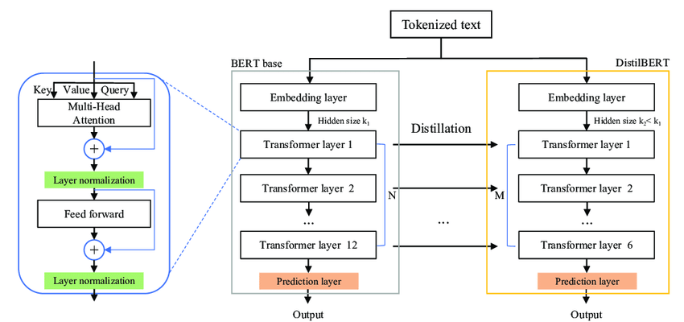

Figure (2): BERT & DistilBERT

* 1. 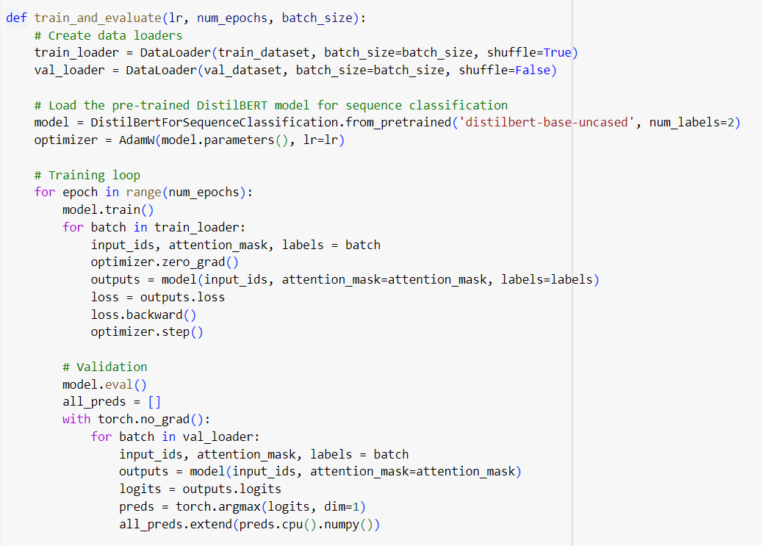**Code Implementation:**

Figure (3): Code Implementation.

**References**

* Doe, A., Johnson, B. (2021). [Natural Language Processing for Disaster Response](https://www.mdpi.com/2504-4990/4/2/20).
* Addison Howard, devrishi, Phil Culliton, Yufeng Guo. (2019). [Natural Language Processing with Disaster Tweets](https://www.kaggle.com/competitions/nlp-getting-started/data).
* Smith, J. (2022). [Natural Language Processing for Disaster Tweets](https://www.kaggle.com/competitions/nlp-getting-started) (Commit SHA).
* Mettler, Cory. (2023). [Developing Gantt Charts](https://www.researchgate.net/publication/371231777_Developing_Gantt_Charts).
* Kumar, Shamanth & Barbier, Geoffrey & Abbasi, Mohammad Ali & Liu, Huan. (2011). [TweetTracker](http://www.researchgate.net/publication/221297827_TweetTracker_An_Analysis_Tool_for_Humanitarian_and_Disaster_Relief).
* Karimiziarani, Mohammadsepehr. (2023). [Social Media Analytics in Disaster Response: A Comprehensive Review](https://www.researchgate.net/publication/372248151_Social_Media_Analytics_in_Disaster_Response_A_Comprehensive_Review).
* Muhammad Imran, Shady Elbassuoni, Carlos Castillo, Fernando Diaz, and Patrick Meier. [Practical Extraction of Disaster-Relevant Information from Social Media. In Proceedings of the 22nd international conference on World Wide Web companion, May 2013, Rio de Janeiro, Brazi](https://mimran.me/papers/imran_shady_carlos_fernando_patrick_practical_2013.pdf).
* Amoudi, Ghada & Almansour, Amal & Watters, Carolyn & Alahmadi, Dimah & Alruwaili, Fatimah & Alzahrani, Sara. (2022). [Tweet for help: the role of social media in disaster events and the case of the 2015 Mina stampede. Digital Creativity](https://www.researchgate.net/publication/367048776_Tweet_for_help_the_role_of_social_media_in_disaster_events_and_the_case_of_the_2015_Mina_stampede).
* Chai, Christine. (2022).[Comparison of text preprocessing methods. Natural Language Engineering](https://www.researchgate.net/publication/361270207_Comparison_of_text_preprocessing_methods).
* Budnik, Ruslan. (2023). [Risks and Prospects of Creativity Tokenization. Journal of Digital Technologies and Law](https://www.researchgate.net/publication/373287157_Risks_and_Prospects_of_Creativity_Tokenization).
* Ghosh, Kripabandhu & Bhattacharya, Arnab. (2017). [Stopword Removal: Why Bother? A Case Study on Verbose Queries](https://www.researchgate.net/publication/325434107_Stopword_Removal_Why_Bother_A_Case_Study_on_Verbose_Queries).
* Wibowo, Sastya & Toyib, Rozali & Muntahanah, Muntahanah & Darnita, Yulia. (2022). [Time complexity in rejang language stemming](https://www.researchgate.net/publication/362890656_Time_complexity_in_rejang_language_stemming).
* Akram, Muhammad & Moosa, Wajid & Najiba, (2023). [From Data Quality to Model Performance](https://www.researchgate.net/publication/376628744_From_Data_Quality_to_Model_Performance).
* Viswanath, Sahana & Shahapure, Nagamani & P M, Rekha & B, Nethravathi & Khandelwal, Pratiksha & Anand, Abhinav & Agrawal, Pranjal & Srivastava, Vedant. (2023). [The DistilBERT Model: A Promising Approach to Improve Machine Reading Comprehension Models. International Journal on Recent and Innovation Trends in Computing and Communication](https://www.researchgate.net/publication/374123033_The_DistilBERT_Model_A_Promising_Approach_to_Improve_Machine_Reading_Comprehension_Models).
* Emmert-Streib, Frank & Moutari, Salissou & Dehmer, Matthias. (2023). [Model Selection](https://www.researchgate.net/publication/374439122_Model_Selection)
* Kuo, Kevin & Thaker, Pratiksha & Khodak, Mikhail & Ngyuen, John & Jiang, Daniel & Talwalkar, Ameet & Smith, Virginia. (2022). [On Noisy Evaluation in Federated Hyperparameter Tuning](https://www.researchgate.net/publication/366423725_On_Noisy_Evaluation_in_Federated_Hyperparameter_Tuning).
* Training, Tonex & Masum, Mostafizur Rahman. (2023). [Scientific Foundations of Test and Evaluation Training by Tonex](https://www.researchgate.net/publication/376416057_Scientific_Foundations_of_Test_and_Evaluation_Training_by_Tonex).
* Elov, Botir & Khamroeva, Shahlo & Khusainova, Zilola. (2023). [The pipeline processing of NLP](https://www.researchgate.net/publication/373072593_The_pipeline_processing_of_NLP). E3S Web of Conferences.
* [Kanwal Mehreen](https://www.kdnuggets.com/author/kanwal-mehreen), KDnuggets, (April 18, 2023), [A Guide to Top Natural Language Processing Libraries](https://www.kdnuggets.com/2023/04/guide-top-natural-language-processing-libraries.html).